# Durable Furnitures

Knowlton

## Classic Country Buffet & Hutch

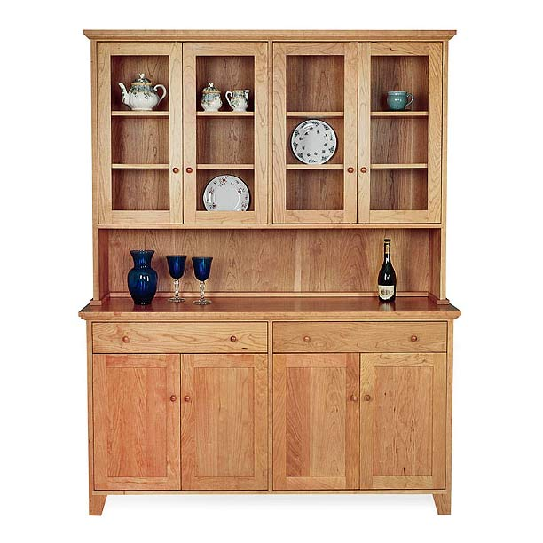

Add plenty of doors, drawers, shelves and extra storage space to your kitchen or dining room with the Classic Vermont Buffet and Hutch. Order today and you will treasure this Buffet and Hutch for generations to come!